Activity:

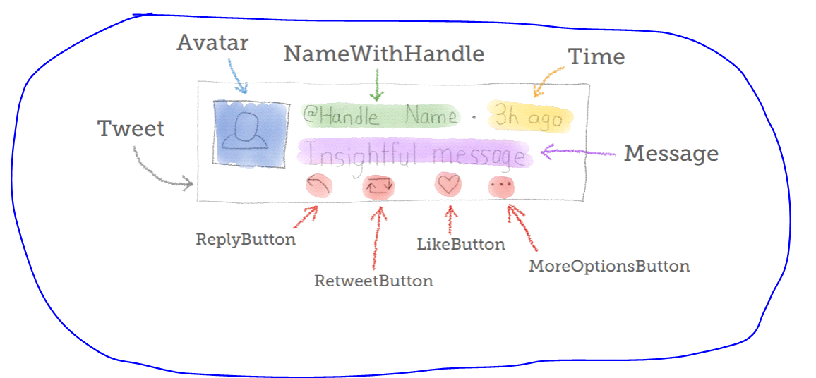

Create rest endpoints:

1. Post new tweet. Count of characters in tweet is less than 144.
2. Get all tweets for username/handlename
3. Like tweet (increase the count of likes by 1)
4. Get total likes for specific tweet (tweetid, handelname/username) of specifc user/handle.
5. Search for tweet containing specific string.